BÀI DẠY ONLINE KHỐI 6 TUẦN 5 +6
TUẦN 5: (4/10-10/10/2021)
UNIT 2: SCHOOL

A. VOCABULARY (TỪ VỰNG)
Lesson 1
No | Words |  | Transcription | Meaning
1 | biology | (n) | /baɪˈɒlədʒi/ | Môn Sinh học
2 | geography | (n) | / dʒiˈɒɡrəfi/ | Môn Địa lý
3 | history | (n) | / ˈhɪstri/ | Môn Lịch sử
4 | I.T (information technology) | (n) | /aɪ ’ti:/ (/ɪnfəˌmeɪʃən tekˈnɒlədʒi/) | Môn Tin học
5 | literature | (n) | / ˈlɪt.rə.tʃər/ | Môn Văn học
6 | music | (n) | / ˈmjuː.zɪk/ | Môn Âm nhạc
7 | P.E (physical education) | (n) | / piː iː /(/ ˌfɪz.ɪ.kəl ed.jʊˈkeɪ.ʃən/) | Môn Thể dục
8 | physics | (n) | /ˈfɪzɪks/ | Môn Vật lý

B. GRAMMAR (NGỮ PHÁP)
I. Using “and”/ “or” for listing
1. We use “and” to join two or more nouns in a positive sentence
I like English and music.
I like English, math and music.
2. We use “or” to join two or more nouns in a negative sentence
I don’t like English or music.
I don’t like English, math or music.

C. EXERCISE (BÀI TẬP)
❶ PHONETICS
I. Choose the words whose underlined part is pronounced differently from that of the others in each group.
1. A. geography B. technology C. negative D. together
2. A. mystery B. fantasy C. music D. sign
3. A. author B. things C. Thursday D. other
4. A. physics B. history C. biology D. literature
5. A. adventure B. math C. capital D. activity
6. A. mountain B. around C. pronoun D. should
7. A. farmers B. problems C. crafts D. animals
8. A. teenagers B. parts C. months D. adults
9. A. games B. tables C. sentences D. movies
10. A. booked B. placed C. missed D. acted

❷ VOCABULARY
II. Write the suitable word for each picture.
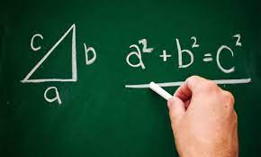 | 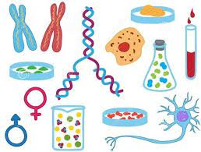 | 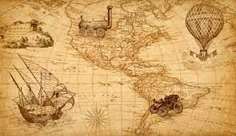
1. | 2. | 3.
 |  | 
4. | 5. | 6.
 | 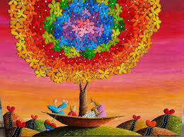 | 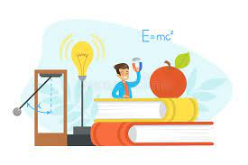
7. | 8. | 9.
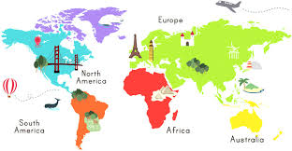 |  | 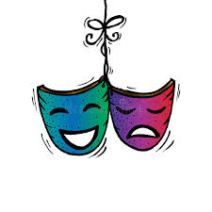
10. | 11. | 12.
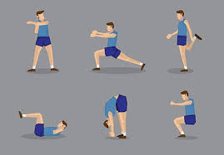 |  | 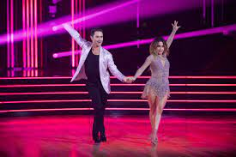
13. | 14. | 15.

III. Read the sentences. Circle the correct answers.
1. I like__________ because I like reading stories.
A. literature B. math C. physics D. biology
2. I like to learn about plants and how they grow. I like__________.
A. I.T B. biology C. history D. math
3. I like computers. That's why I like__________.
A. I.T B. P.E C. history D. physics
4. I love to learn about mountains and rivers. I like__________.
A. I.T B. physics C. English D. geography
5. I don't like running and playing sports. I don't like__________.
A. literature B. P.E C. math D. history
6. Studying helps me learn about countries around the__________ world and famous people in the past.
A. music B. history C. biology D. math
7. I love to learn how light, heat, and sound work. I love__________.
A. geography B. biology C. physics D. music

TUẦN 6 (11/10/17/10/2021) UNIT 2: HOME –LESSON 2
- VOCABULARY (TỪ VỰNG)
Lesson 2
No | Words |  | Transcription | Meaning
9 | act | (v) | / ækt/ | Diễn xuất
10 | activity | (n) | / ækˈtɪvəti/ | Hoạt động
11 | arts and crafts | (n) | / ˌɑːts ən ˈkrɑːfts/ | Thủ công mỹ nghệ
12 | drama club | (n) | / ˈdrɑː.mə klʌb/ | Câu lạc bộ kịch
13 | indoor | (adj) | / ˌɪnˈdɔːr/ | Trong nhà
14 | outdoor | (adj) | / ˈaʊtˌdɔːr/ | Ngoài trời
15 | sign up | (v) | / saɪn ʌp/ | Đăng ký

B. GRAMMAR (NGỮ PHÁP)

II. Possessive pronouns: mine and yours
My favorite subject is English. What’s yours?
Mine’s math.

C. EXERCISE (BÀI TẬP)

I. Fill in the blanks using the words in the box.
sign up | drama club | arts and crafts | indoor activities | indoor activities | act
1. Why don't you______________ for a book club?
2. Chris wants to be an actor. He's learning how to______________ at school.
3. Jane likes acting. She joined the______________ at school.
4. Some students love doing______________ because they can make pretty things from paper.
5. Volleyball and table tennis are______________. We often play them in the sports center.
6. Many students like playing soccer and tennis. They're ______________.

II. Fill in the blanks using the words in the box.
sign up | history | arts and crafts | fantasy | novel | geography | drama club | literature
1. My favorite subject is______________ I like learning about people in the past.
2. Harry Potter is a famous______________ series. Many people love the magical world in the books.
3. There are many______________ projects before the holidays. You can learn how to make beautiful cards and decorations.
4. Her first______________ is about her childhood in the south of India. Many people, especially girls and women, love it because they can see themselves in her story.
5. Why don't you______________ for an outdoor activity? Being outdoors is great for your health.
6. Matt doesn't like______________. He thinks all the books he has to read in the class are boring.
7. We learn about different countries in______________ class.
8. The______________ is looking for actors for their new play.

IV. Underline the correct words.
1. My favorite sport is tennis. What’s mine/ yours? - I like soccer.
2. I found a bag. Is it mine/ yours? - No, it isn't. My bag is here.
3. This book isn't my book. Mine/Yours is blue. Is it yours? - Yes, it is.
4. I saw a red hat on the table. Isn't yours/mine red? - No, mine is blue.
5. What's your favorite ice cream? Mine/Yours is chocolate. - I like chocolate, too.
6. Do you have a ruler? Mine/Yours is at home. - Sure, here you are

V. Underline the correct word for each sentence.
1. Is this cup _______________ (your / yours)?
2. The coffee is _______________(my/mine).
3. That coat is _______________ (my/mine).
4. He lives in _______________ (her/hers) house.
5. You might want _______________ (your/yours) phone.
6. The new car is _______________ (their/theirs).
7. She cooked _______________ (our/ours) food.
8. Don't stand on _______________(my/mine) foot!
9. She gave him _______________ (her/hers) suitcase.
10. I met _______________ (their/theirs) mother.
11. Is this _______________ (their/theirs) coffee?
12. Is the flat _______________ (her/hers)?
13. The grey scarf is _______________ (my/mine).
14. That red bike is _______________ (our/ours).
15. We should take _______________ (our/ours) coats.
16. That is _______________ (my/mine) car.
17. He dropped _______________ (my/mine) bag.
18. Are these phones _______________ (their/theirs)?
19. These cakes are _______________ (our/ours)!
20. Are those children _______________ (your/yours)?

VI. Circle the word that differs from the other three in the position of primary stress in each of the following questions.
1. A. music B. outdoor C. novel D. correct
2. A. physics B. event C. author D. perform
3. A. biology B. geography C. literature D. technology
4. A. adventure B. fantasy C. mystery D. history
5. A. education B. information C. intonation D. television
6. A. drama B. baseball C. suggest D. subject
7. A. literature B. biology C. activity D. geography
8. A. music B. soccer C. physics D. indoor
9. A. fantasy B. history C. favorite D. adventure
10. A. novel B. decide C. author D. science

